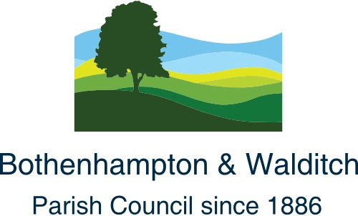

Mr B Turner
West Dorset District Council
South Walks House
South Walks Road
Dorchester
Dorset
DT1 1UZ
18th February 2020
Dear Blair

RE: WALDITCH SPEED LIMIT

We refer to our letter to you of 18th October 2019. We are pleased that the consultation process initiated on 28th November 2019 has now been concluded however, we do not know the results of the consultation and whether the Traffic Regulation Order was acceptable to the Walditch community.

As there was a commitment from Dorset Council to begin work on this TRO prior to the end of the 2019/20 financial year we are wondering whether there has been a hitch (consultation outcome) and if not, when Dorset Council intend to begin this work.

Please accept our apologies Blair if this letter is not to be addressed to you, and should this be the case, please could you forward it to the person responsible at Dorset Council.
Yours sincerely,
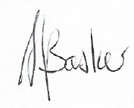
A J Basker
Chairman
Bothenhampton & Walditch Parish Council
www.bothenhamptonwalditchparishcouncil.com

cc: Mr Mike Potter

